**Identification of Possible Alternatives to Maximize Profit for Bear River Project Hydropower System**

**Introduction: Location and Primary Stakeholder.**

The Bear River, located near the border of Idaho, Wyoming and Utah, stretches 491 miles throughout the Uinta Mountains. The river is primarily used for irrigation throughout the area but does offer some recreational use through the three states of Idaho, Utah and Wyoming. Of its many uses, the Bear River is a source of hydroelectricity for the surrounding communities. The primary stakeholders in charge of Bear River power production PacifiCorp, a leading utility operators in the midwest US. PacifiCorp has three primary purposes for the Bear River: hydropower production, flood control, and water supply through the Bear River Project (BRP). The BRP is a series of rivers and reservoirs that generate a total of 107-megawatt (mw) worth of hydroelectric energy. The BRP is largely dependent on the irrigation water diverted from Bear Lake, located in Northern Utah. The BRP consist of three primary reservoir and dams for the production of hydroelectricity: Soda (Alexander), Grace, and the Oneida development. A more detailed description of these three sites can be found later in the reservoir description section.

**History: Bear River Project Water Rights**

In agreement with the three states of Wyoming, Idaho and Utah, PacifiCorp’s primarily responsibility for the BRP is the protection from floods and the release of reservoir water for irrigation. In addition to mentioned state guidelines, PacifiCorp must meet the following demands on water rights for the following companies.

Sugar Company: As part of the 1912 Sugar Company Conveyance and Agreement (the “Sugar Company Contract”), PacifiCorp must supply a minimum of 900 cfs during the irrigation season and 150 cfs during the non-irrigation season. However, with the exception of years with high spring runoff and flood chance, there is insufficient water flowing in the Bear River to make the specified water delivery target for the Sugar Company Contract. The contract states that if any time PacifiCorp fails to make the target delivery, then PacifiCorp must pump water stored in Bear Lake into the delivery canal to meet the guaranteed irrigation water deliveries for the Sugar Company. As such, PacifiCorp must balance its release along with its storage to meet this demand.

Last Chance Canal Company: In 1919, PacifiCorp formalized its Bear Lake relationship with Last Chance by entering into an irrigation contract with Last Chance for supplemental irrigation water stored in and released from Bear Lake. That contract is called the Last Chance Canal Company Contract, and like the Sugar Company Contract, states that PacifiCorp must meet release target delivery targets.

Other Irrigation Contracts / New Contracts: In addition to the two previously mentioned water right contracts listed above, PacifiCorp does have similar agreements with other stakeholders. For example, in 1916 and 1919 respectively, PacifiCorp entered into a contract with two smaller pumping companies known as Cub River Irrigation Company and the West Cache Irrigation Company. Throughout the years it has become increasingly difficult for PacifiCorp to meet the target deliveries of every stakeholder. As such, no new contracts are allowed to be made. Not only is there not enough water stored in Bear Lake for any new irrigation contracts, there is little enough currently stored in Bear Lake for licensing purposes of existing contracts.

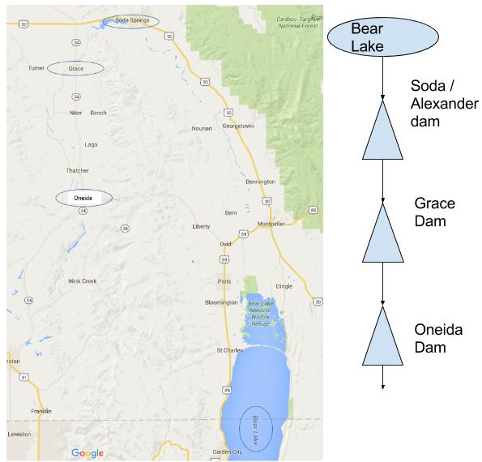

Figure 1:A)On the left: Location of Three Reservoir Sites with Respect to Bear Lake, B) On the right: Schematic Diagram of the three reservoir and the Bear Lake

Amended Bear River Compact: The Bear River Compact, approved by Congress in 1980 and ratified by the states of Wyoming, Idaho and Utah, was created, among other things, “*to accomplish an equitable apportionment of the waters of the Bear River among the compacting States.*” (Bear River Settlement Agreement Explanatory Statement 2002). The Compact claims that PacifiCorp is the sole owner of the right to store and release water from Bear Lake. However, they must not release water from the lake except to satisfy the irrigation contracts when the lake is below the irrigation reserve. This reserve level is now calculated at a water surface of elevation 5912 feet. This means that when the water drops below this point, PacifiCorp may not release water for anything but irrigation. When this occurs, this is a loss of profit for PacifiCorp in hydropower generation and recreational use of the three reservoirs areas.

**Bear River Project: Reservoir and Dam Description**

**Soda Dam**: Also known as Alexander Dam, is located in southern Idaho just north of Bear Lake, and is the first stop of the BRP. Built in 1925, Soda Dam is a concrete gravity feed structure 94 feet tall with a length of 492 feet. Soda has a maximum possible discharge of 17,580 cfs, but is constricted down to 2,624 cfs for operations. Soda dam is the largest of the three sites and has a capacity of approximately 16,300 acre feet. However, due to the increased demand of recreational use of the reservoir and the previously mentioned operation control the capacity is reduced down to 15,760 acre feet. Normal operating water surface height is 5,719 feet with a maximum height of 5,735 possible. Despite it size, soad has the smallest power house available and can only generates about 14 MW worth of power.

There are three existing recreational facilities within the Soda Dam Boundaries that PacifiCorp owns and maintains: a small day use area at the downstream end of Soda Reservoir near Soda Dam; a second day use area on the reservoir about 0.5 mile upstream of Soda Dam known locally as Second Bridge site; and the Oregon Trail Park on the reservoir near Soda Springs.

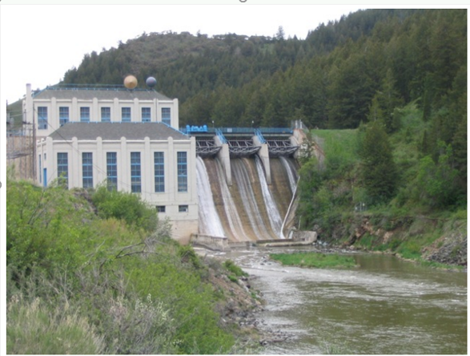

Figure 2: Soda Dam Powerhouse

**Grace:** The second stop for the BRP is the Grace Dam. The Grace Dam is the smallest of the three sites at a height of 48 feet and a length of 180 feet. The normal storage capacity is 320 acre feet. Grace consists of two hydroelectric developments that can generate a total of 40.5 MW worth of hydroelectricity.

Grace is considered forebay reservoir to the Oneida Reservoir. A forebay is an artificial pool of water in front of a larger body of water used as a 1) flood control buffer, 2) location to trap sediment and debris, 3) an additional control and storage for the lower larger reservoir. As such, the Grace Reservoir has no seasonal storage capacity to speak of.

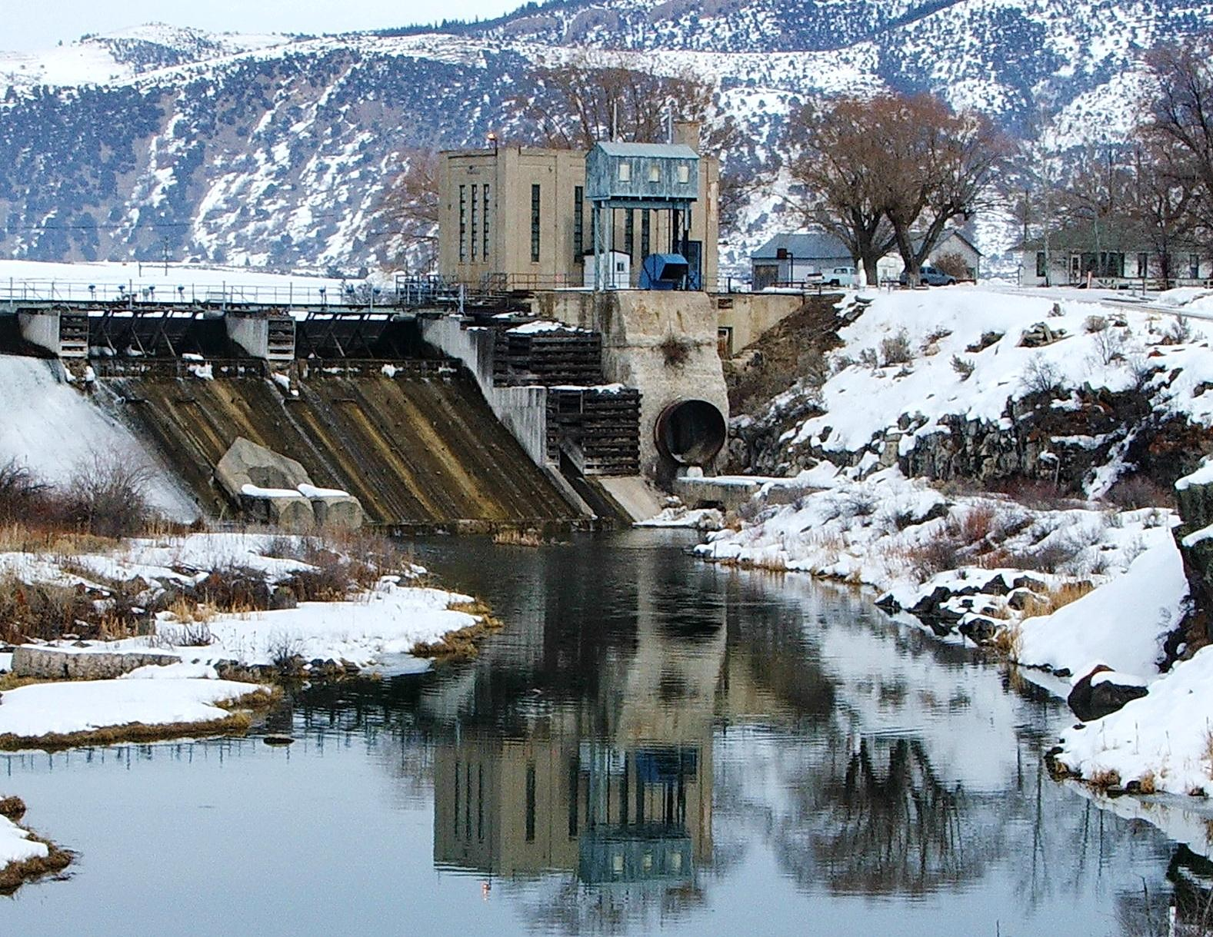

Figure 3: Grace Dam Powerhouse

**Oneida:** Oneida is the last stop for the BRP before the river collects and pools into the Cutler reservoir in Cache Valley. Like Soda, Oneida is a concrete gravity feed am with a height of 102 feet and length of 456 feet. It has a storage capacity of 11,500 acre-feet. When full, the reservoir has an average depth of about 28 feet, with a maximum depth of about 85 feet in some spots. Oneida Dam can generate up to 30 MW of hydroelectric power.

Oneida Reservoir sports one of the area's more popular recreation spots for camping, fishing, and boating. Downstream of the reservoir itself is whitewater rafting area, perfect for beginning boaters. As such, PacifiCorp is responsible for maintaining adequate flows and water levels needed for these these recreational facilities. PacifiCorp currently accommodates these needs by limiting releases below the reservoir to 500 cfs for several hours on weekends in the summer.

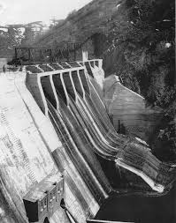

Figure 4: Oneida Dam Powerhouse

**Stakeholder Problem: Lack of Available Resources**

The following is a description of the problems PacifiCorp faces in the operation and maintenance of the BRP.

In all but flood years, there is insufficient water flowing naturally in the Bear River to make the guaranteed water delivery targets of the Bear River Stakeholders (like Sugar Company). To make up for these low flows, PacifiCorp must pump water it has previously stored in Bear Lake into a canal to meet the guaranteed irrigation water deliveries.

Due to the Bear River Compact, however, releases from Bear Lake storage water to satisfy instream flows would and can violate federal and state law PacifiCorp has agreed upon. In accordance with the Compact, Pacificorp must maintain a water surface elevation of 5,912 feet in Bear Lake.

In addition to the limitations for water distribution set by water rights and the Bear River Compact, PacifiCorp has the additional problem of not allowing any new contracts to be filled or made. The water currently stored in Bear Lake / the BRP is stretched thin and does not allow the incorporation of any new contracts, where new contracts could be a potential new revenue source for PacifiCorp.

**Project Goals and Intentions: Proposed Solutions**

Project Objectives:As an utility operator, PacifiCorp is in the business of producing a profit. This project’s aim is to look into a number of alternative approaches that could maximize the potential profit generation of PacifiCorp. This will be accomplished by measuring the potential earnings made through the use of the proposed management alternatives compared to PacifiCorp's maximum hypothetical potential revenue possible. However, PacifiCorp must do so fulfilling their primary responsibility of flood protection and irrigation release for the surrounding area and a number of other constraints:

1. Limited inflow / recharge of Bear Lake with seasonal change
2. Responsibility to meet the flow demands of all listed stakeholders (like Sugar Company)
3. Restrictions in lowering the water surface elevation of Bear Lake to below 5,912 feet

Proposed Management Alternatives / Performance Metrics:

Following is a list of the proposed alternatives to meet the above stated objective of increasing profit for PacifiCorp.

* New Reservoir: this project will test how the inclusion of a new reservoir affects the total system for flow. The performance metrics will be observing how well water demands are met currently.
* New Source of Water: Bear Lake’s limited supply does not allow for new contracts to be made. New contracts would bring in new revenue for PacifiCorp. This project will research potential new sources for Bear Lake. The performance metrics will be observing how much new revenue will be brought in with the new source.
* Gravity Fed System: Currently, PacifiCorp must pump stored water in Bear Lake out if they need to meet the flow demands of the listed stakeholders. Pumping can be a costly practice, and this project will research cost savings from potential solutions for allowing water to be gravity fed into the canal instead of pumping. The performance metrics will be observing how much money could be saved if PacifiCorp did not pump.
* Lowering rate of sediment accumulation so that the rate of reduction in reservoir capacity is reduced.

However, given the time constraint, all of the alternatives may not be viable to evaluate in the complete version of the report.

Data Acquisition: Historical flow data in and out from each of the dam can be found through the Bear River Commision services through the provided link: <http://bearriverbasin.org/>. The site also hosts data related to reservoir and the bear lake elevation records.

However, there is still some data that we are not sure where to get from. The data that we are still trying to obtain include reservoirs volume to depth relationship, and the rules based on which the reservoirs operate.

Future Steps: Future works in the project include collection of remaining data most of which are dams related. Creation of BRP model in WEAP, and evaluate future earnings by the PacifiCorp. Also, identification of the major sources of water, and the demand points is required to do a comprehensive modeling in WEAP

**References:**

### *Bear River Settlement Agreement Explanatory Statement.* 28 AUG 2002. <<http://www.lowimpacthydro.org/assets/files/Bear%20River%20ID/Bear_River_Settlement_Agreement_Explanatory_Statement.pdf>>

* PacifiCorp. *Bear River Project*. 2016. <<http://www.pacificorp.com/es/hydro/hl/br.html>?>
* Bear River Commision. <http://bearriverbasin.org/>